[PhysicalEducation,HealthandSocialSciences](https://journal-of-social-education.org/index.php/Jorunal/index)

[https://journal-of-social-education.org](https://journal-of-social-education.org/)

**E-ISSN:**[2958-5996](https://portal.issn.org/resource/ISSN/2958-5996)

**P-ISSN:**[2958-5988](https://portal.issn.org/resource/ISSN/2958-5988)

**The Mediating Effect of Students Interest in Learning, in the Relationship Between Teacher Leadership Skills and Students Self- Efficacy**

**Dr. Mehnaz Fazal1, Maria Gogosh2, Bibi Zam Zam3**

**1** Lecturer, Department of Education, University of Malakand WSCB**,**

Email: [educationist.mehnaz@uom.edu.pak](mailto:educationist.mehnaz@uom.edu.pak)

**2** Lecturer in Department of Comemerce and Management Sciences, University of

Malakand, WSCB, Email: [mariabashir92@gmail.com](mailto:mariabashir92@gmail.com)

**3** BS Student, Department of Education, University of Malakamd, WSCB

# *DOI:* *https://doi.org/10.63163/jpehss.v3i3.541*

# Abstract

This study looked at how teachers' leadership skills, students' confidence in their own abilities, and students' engagement learning were related. The Krejcie and Morgan table was used to choose a sample of 144 students from a population of 230. We employed a five-point Likert scale to get the information. The reliability coefficients were 0.93 for leadership skills, 0.921 for self-efficacy, and 0.88 for student interest in learning. The results showed that all three factors were strongly related in a positive way. Also, students' engagement in learning was partially mediating the effect of teachers' leadership skills on students' self-efficacy. These results show how important it is for instructors to be good leaders in order to help pupils feel confident and interested in studying. The results of the study have an impact on policy and practice in education. Based on the results, two main suggestions are made: Teachers should work on and improve their leadership abilities so that they can establish a learning atmosphere that is interesting and supportive, which will make students more interested in studying and boost their confidence. Schools should offer teachers professional development opportunities and training programs to help them become better leaders so they can better help children grow and learn.

**Introduction**

Teacher leadership and self-efficacy are important for improving the quality of education in the 21st century (Calkins et al., 2024). As the world of education gets more complicated and the need for better results grows, teachers' roles have changed from just passing on information to being active participants and leaders in educational reform (Galdames, 2023).This change shows that people expect more from schools and teachers are becoming more important in making decisions about school rules and cultures (Midgley et al., 2000).Teacher leadership goes beyond just running the school and now has a huge impact on the whole educational system through both formal and informal roles inside and outside of school (Midgley et al., 2000).This change shows how important teachers are in bringing forth new ideas in academics and education. It also shows how much they can motivate students to learn and do better. To create a learning atmosphere that helps students succeed, teachers need to have good leadership abilities (Bandura, 1997). Self-efficacy is the idea that you can do well in certain situations or tasks (Bandura, 1997). Students with strong self-efficacy are more likely to take on difficulties, keep going when things become tough, and reach their academic goals. Studies have shown that teachers who are good at things like leading lessons, giving emotional support, and managing the classroom can have a big effect on how confident pupils feel in their own abilities (Midgley et al., 2000). Teacher leadership is also connected to the practice of virtues (VanderWeele, 2017) and character education (Lickona, 2006). Students develop higher morals when their teachers show interest, care, and concern for them, talk to them, and help them find meaning and purpose in hard times.In school, students' beliefs about how well they can learn affect how well they think they can do in school, which in turn affects the goals they set for themselves and their final grades ((Zimmerman, & Martínez-Pons, 2012). According to social cognitive theory ((Graham, 2022), students who believe in themselves more are more likely to want to study and do well in school. The student's interest to learn, on the other hand, is a key influence in their academic motivation and engagement, as well as their self-efficacy (Hidi & Renninger, 2006). Students are more likely to want to learn, keep going when things become tough, and feel like they can do things when they are engaged in a subject or topic (Schiefele, 2000).More study shows that students' interests in learning can affect the link between teaching methods and student outcomes, such as self-efficacy. This is because teachers' leadership qualities can affect students' interests, which can then affect their confidence and self-efficacy(Hidi & Renninger, 2006).Teacher leadership skills can foster both interest and self-efficacy in students……… Research suggests that supportive and engaging teachers help students develop confidence and sustain interest in learning (Leithwood et al., 2004). Student interest mediates the impact of teacher leadership on self-efficacy by maintaining students’ emotional and cognitive involvement (Hidi & Renninger, 2006). There have been a lot of studies on teachers' leadership qualities and self-efficacy. But meager research has been found on the mediation aspect of student’s interest in learning. Based on the above literature, the researcher used students' interest in learning as a mediator between leadership skills and students' self-efficacy. This study adds to the theory of how important it is for students to believe in themselves and be interested in learning from a good teacher.

## Problem statement

The academic experiences and results of students are significantly shaped by the quality of teacher leadership skills. One important outcome is students' interest and self-efficacy, or their belief in their capacity to reach academic objectives. Even though there have been efforts to make education better in Pakistan, many kids don't want to learn, which sufferings their grades and self-confidence. This problem is made worse by traditional educational methods, not enough resources, and big class sizes. Because of this, children frequently don't develop a real love of learning, which leads to bad grades and less opportunities in the future.Many studies on self-efficacy and leadership have been done. This study looks into the link between teacher leadership skills, student interest, and self-efficacy in Pakistani educational institutions. Specially, focused onthe mediating function of students' interest in the connection between teacher leadership skills and students' self-efficacy. Thus, this study makes a major contribution to the current body of knowledge.

## Objectives

1. To examine the relationship between leadership skills of teachers and students self-efficacy
2. To examine the relationship between leadership skills of teachers and students interest in learning
3. To find out the relationship between students interest in learning and their self-efficacy
4. To find out the mediating role of students interest in learning between leadership skills of teachers and students self-efficacy

## Research Questions

1. What is the relationship between leadership skills of teachers and students self-efficacy
2. What is the relationship between leadership skills of teachers and students interest in learning
3. What is the relationship between students interest in learning and their self-efficacy
4. What is the mediating role of students interest in learning between leadership skills of teachers and students self-efficacy

## Hypotheses

H1: There is significant positive relationship between leadership skills of teachers and students self-efficacy

H2: There is significant positive relationship between leadership skills of teachers and students interest in learning

H3: There is significant positive relationship between student’s interest in learning and their self-efficacy

H4: There is significant mediating role of student’s interest in learning between leadership skills of teachers and self-efficacy of students

## Significance of the Study

This study is important because it could help us learn more about how teacher’s leadership qualities affect students' self-efficacy, especially how students' motivation in studying at the University of Malakand plays a role in this. By looking into this connection, this study can give teachers useful information on how to create a supportive learning environment that encourages students to be involved and motivated. Moreover, this study can help students learn better and stay motivated by giving them answers that work in their own setting. The study's results can also add to the body of research on teacher leadership skills, student self-efficacy, and their enthusiasm in learning, helping us to better understand these complicated relationships. This study can help figure out how to boost students' motivation, confidence, and overall academic performance by showing how student interest in learning might act as a mediator.Overall, this study could have a big impact on how education is done at the University of Malakand and other places.

# Research Methodology

We used a descriptive survey and a quantitative study to get reliable and important information regarding teachers' leadership skills, self-efficacy, and student’s interest in learning. The study's participants were male and female undergraduate students from the University of Malakand who were studying in a variety of fields, including Urdu, Psychology, Education, English, Islamic Studies, and Economics. The current study has a total of 230 students. The overall sample size for this study is 144, which was found using the Krejcie and Morgan (1970) sampling table. After that, the researcher picked samples at random from different departments. The researcher constructed their own questionnaire for the study, which employed a five-point Likert scale with options from Strongly Disagree (SD) to Strongly Agree (SA). The five-point Likert scale questionnaire utilized in this study has three parts and 33 questions. A pilot study was conducted for testing the questionnaire with a small sample of participants. The reliability of the questionnaire was0.93 for Leadership Skills, 0.92 for self-efficacy and 0.886 for Interest of Students in Learning.

**Data Analysis, Results and Discussion**

The overall sample size for this study was 144 and the researcher picked samples at random from different departments.

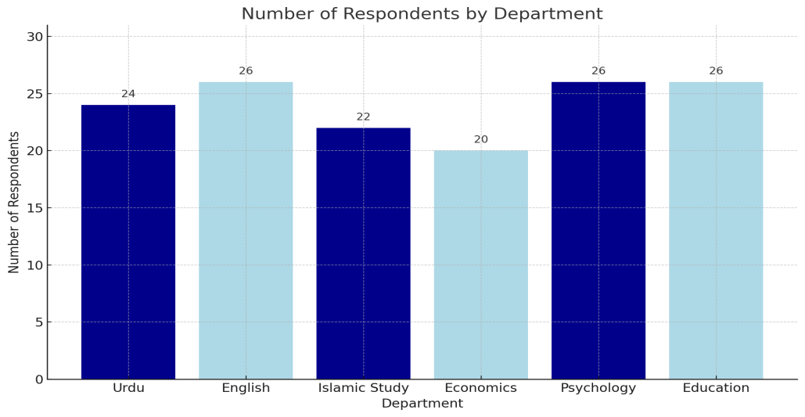

**Figure 1:** Department-Wise Distribution of the Sample

**Hypothesis 1**

The result showed that LS had a significanteffect on SE, as showed in Figure 4.1. The path from LS to SE was extensively positive at level 0.001. The value of beta coefficient (β) is 0.59, critical ratio (C.R) is 6.539 while probability value is p<.01). Which proposed, LS have significant positive influence on SE.The C.R number (C.R= 9.539 > 1.960) was higher than the T table value, which means that LS has a positive and important effect on SE. The p value, which is less than 0.05, also made this significance stronger.So, H1was accepted.

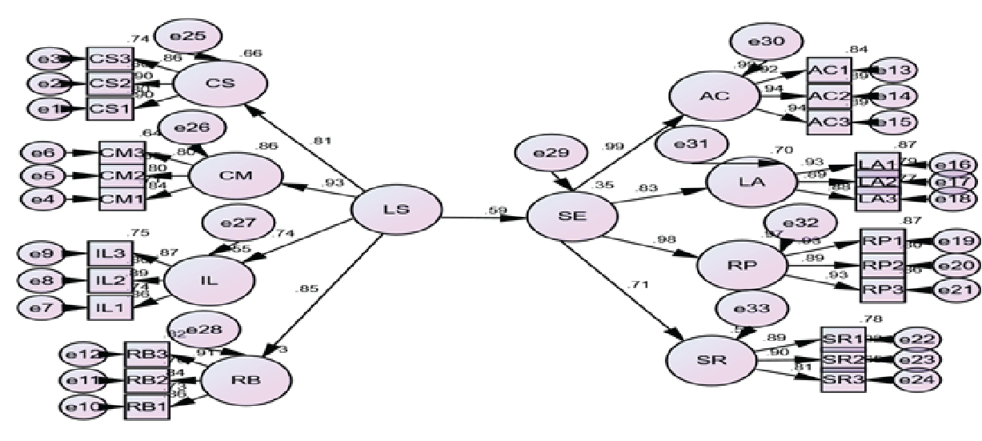

**Figure 2 :** The influence of LS on SE

H2: There is significant the relationship between leadership skills of teachers and students interest in learning

The result showed that LS had a substantial and advantageous effect on INT, as illustrated in Figure 4.2. The path from LS to INT was extensively positive at level 0.001. The value of beta coefficient (β) is 0.89, critical ratio (C.R) is 8.226 while probability value is p<.01) proposed, LS have significant positive influence on INT of student’s.This significance was strengthened by p value which is lower than 0.05) .Therefore, H2 was accepted.

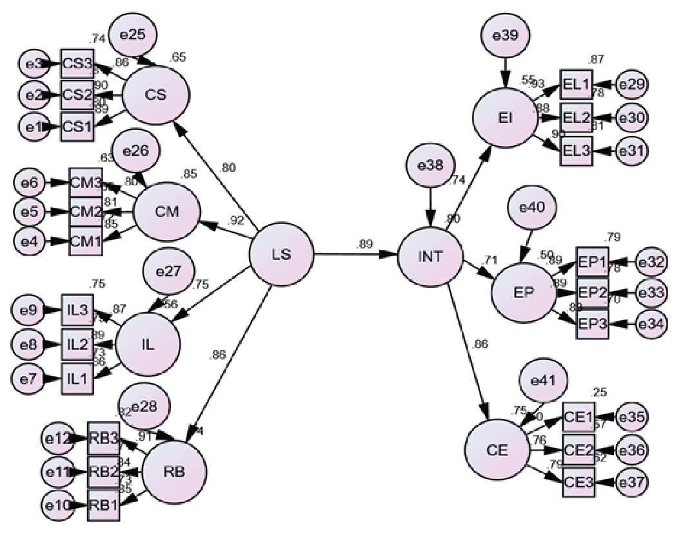

**Figure 3 :** The influence of LS on INT

H3: There is significant the relationship between students interest in learning and self efficacy

The result showed that INT had a substantial and advantageous effect on SE, as demonstrated in Figure 4.3. The path from INT to SE was extensively positive at level 0.001. The value of beta coefficient (β) is 0.82, critical ratio (C.R) is 7.458 while probability value is p<.01) proposed, INThave significant positive influence on SE of student’s.This significance was strengthened by p value which is lower than 0.05) Therefore, H3 was accepted.

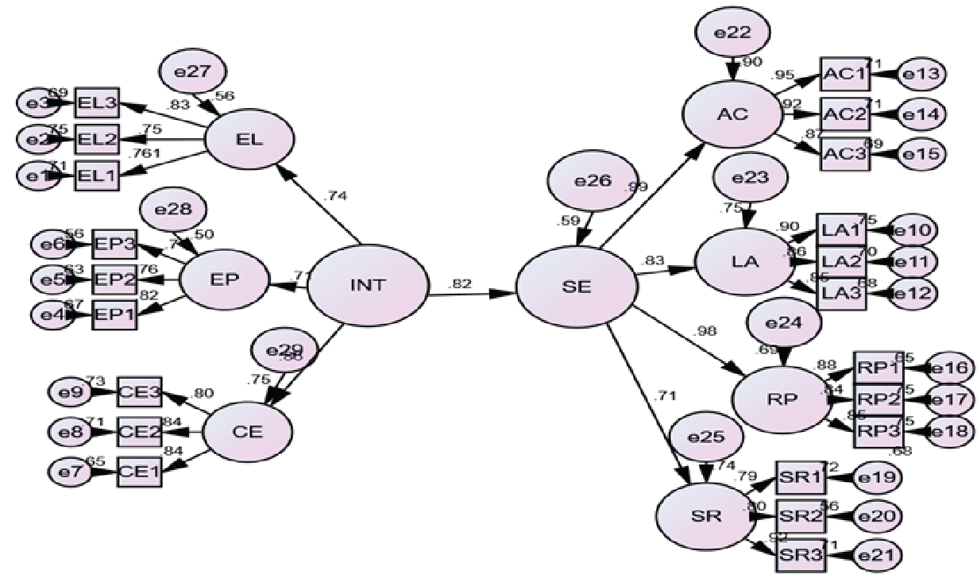

**Figure 4 :** The influence of INT on SE

H4: There is significant mediating role of student’s interest in learning between leadership skills of teachers and self-efficacy of students

## Using Bootstrapping Method to test Hypothesis H4:

In order to explore the mediating impact of Interest of students in learning (IINT) on the association between leadership skills (LS) of teachers and self-efficacy of students (SE), we implemented a mediation analysis. The results are showed in Table 1, which shows a remarkable indirect effect of Leadership Skills (LS) on self-efficacy (SE) through INT (H4: β = 0.201, p< 0.001). LS had an overall impact on SE that was statistically significant (β = 0.59, p < 0.001). The direct effect of LS on SE was also significant in the presence of a mediator (β = 0.47, p < 0.001). This suggests that the Interest of students in learning,functions as a partial mediator in the relationship between LS and SE. As a result, we accepted hypothesis four.

**Table 1**

*Mediation analysis (Bootstrapping by Amos) summary*

|  |  |  |  |  |  |  |  |  |  |
| --- | --- | --- | --- | --- | --- | --- | --- | --- | --- |
| **Total**  **Effect**  LS->SE | | **Direct**  **Effect**  LS->SE | | **Hypothesis** | **Indirect**  **Effect**  LS->SE | | **Confidence Interval** | | **Conclusion** |
| β- Value | p-Value | β- Value | p-Value | Ho7:LS->INT->SE | β- Value | p-Value | Low  Bound | Upper  Bound | **Partial Mediation** |
| 0.59 | .004 | 0.47 | 0.040 | 0.201 | 0.001 | 0.129 | 0.450 |

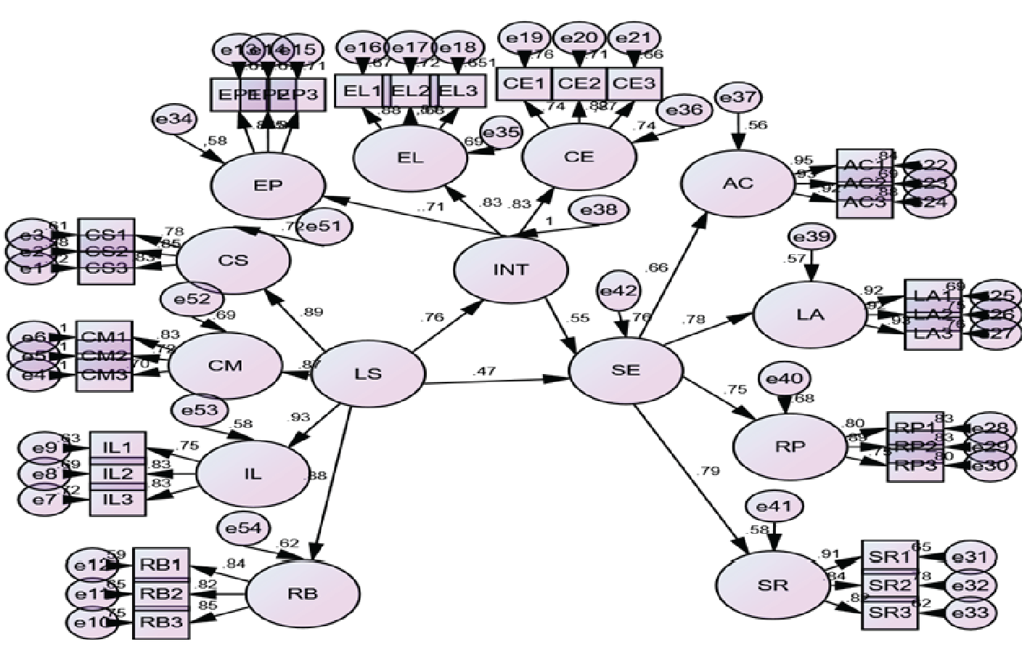

**Figure 5 :** INT contribute as a mediator between LS and SE

## 

## Findings

Teacher leadership skills have a big effect on how confident students feel in their own abilities. When teachers are good leaders, they create a supportive learning atmosphere that encourages students to take charge of their own learning. Teachers can also boost students' self-efficacy by giving them constructive feedback. Teachers who believe in their own abilities are more likely to use new ways of teaching, run the classroom well, and meet the needs of all of their students. In turn, this can have a favorable effect on students' outcomes, the general quality of education, and students' sense of interest and self-efficacy. The finding of the study revealed a strong positive relationship between teacher’s leadership skills, student’s self-efficacy and their interest in learning. The study has focused on the mediating effect of student interest in learningbetween LS and SE.The result demonstrated a significant but indirect effect of LS on SE through student’s interest in learning suggests that student’s Interest in learning, functions as a partial mediator in the relationship between LS and SE.

## Discussion

The results of this study show that students' desire in learning is a very important factor in the link between teachers' leadership qualities and students' self-efficacy. More specifically, the results show that teachers who are good leaders make pupils more interested in learning, which makes them feel more capable. This effect shows how important it is for teachers to be able to inspire and motivate their students, since this might affect their confidence and ability to do well in educational institution. Teachers may make learning more interesting for students by encouraging them to be interested in it. This gives pupils a sense of self-efficacy, which leads to better academic results. These results have consequences for teacher professional development. They imply that training programs that focus on leadership abilities and getting students involved can help children feel more confident and do better in school.

## Conclusions

In conclusion, the study shows how important it is for teachers to have leadership abilities in order to help students believe in themselves. This is true both directly and indirectly, with students' enthusiasm in learning acting as a partial mediator. Teachers may make learning environments that help students build their confidence, motivation, and general success by improving their leadership skills and getting students interested in learning.

## Recommendation

The following recommendations are thus provided to HODs, Policy makers, Researchers, Parents, and Students in order to enhance leadership abilities.

## For Teachers

1. Teacher should engage in professional development opportunities to enhance leadership skills such as effective communication, decision making ability.
2. Incorporate strategies to develop student’s interest in learning.
3. Develop positive and supportive relationship with students to enhance their self-efficacy.

**For Government**

1. Providing resources and funding for teachers professional development programs focused on leadership skills.
2. Monitor the impact of teacher leadership skills on student’s outcomes.

**For Future Research**

1. Investigate the factors that influence the relationship between teacher leadership skills and students self-efficacy.
2. Longitudinal study should apply to find out the impact of leadership skills on students self-efficacy.
3. Investigate the relationship in various educational setting and culture.

# References

Bandura, A., & Wessels, S. (1997). *Self-efficacy* (pp. 4-6). Cambridge: Cambridge University Press.

Calkins, L., Wiens, P., Parker, J., & Tschinkel, R. (2024). Teacher motivation and self-efficacy: how do specific motivations for entering teaching relate to teacher self-efficacy?. *Journal of Education*, *204*(2), 427-438.

Cassata, A.; Allensworth, E. Scaling standards-aligned instruction through teacher leadership: Methods, supports, and challenges. *Int. J. Stem Educ.* **2021**, *8*, 39.

Datnow, A. The role of teachers in educational reform: A 20-year perspective. *J. Educ. Chang.* **2020**, *21*, 431–441.

Galdames-Calderón, M. (2023). Distributed leadership: School principals’ practices to promote teachers’ professional development for school improvement. *Education Sciences*, *13*(7), 715.

Graham, S. (2022). Self-efficacy and language learning–what it is and what it isn't. *The Language Learning Journal*, *50*(2), 186-207.

Harris, A. (2003). Teacher leadership as distributed leadership: heresy, fantasy or possibility?. *School leadership & management*, *23*(3), 313-324.

Krapp, A. (2002). Structural and dynamic aspects of interest development: Theoretical considerations from an ontogenetic perspective. *Learning and instruction*, *12*(4), 383-409.

Leithwood, K., & Jantzi, D. (2005). Transformational leadership. *The essentials of school leadership*, *31*, 43.

Leithwood, K., Seashore, K., Anderson, S., & Wahlstrom, K. (2004). Review of research: How leadership influences student learning.

Muijs, D.; Harris, A. Teacher-led school improvement: Teacher leadership in the UK. *Teach. Teach. Educ.* **2006**, *22*, 961–972.

Pajares, F. (1996). Self-efficacy beliefs in academic settings. *Review of educational research*, *66*(4), 543-578.

Renninger, K. A., & Hidi, S. (2011). Revisiting the conceptualization, measurement, and generation of interest. *Educational psychologist*, *46*(3), 168-184.

Schiefele, U. (1991). Interest, learning, and motivation. *Educational psychologist*, *26*(3-4), 299-323.

Schott, C.; van Roekel, H.; Tummers, L.G. Teacher leadership: A systematic review, methodological quality assessment and conceptual framework. *Educ. Res. Rev.* **2020**, *31*, 100352.

Shal, T.; Ghamrawi, N.; Abu-Tineh, A.; Al-Shaboul, Y.M.; Sellami, A. Teacher leadership and virtual communities: Unpacking teacher agency and distributed leadership. *Educ. Inf. Technol.* **2024**, 1–18.

Wray, E.; Sharma, U.; Subban, P. Factors influencing teacher self-efficacy for inclusive education: A systematic literature review. *Teach. Teach. Educ.* **2022**, *117*, 103800.

York-Barr, J., & Duke, K. (2004). What do we know about teacher leadership? Findings from two decades of scholarship. *Review of educational research*, *74*(3), 255-316.

Zimmerman, B. J. (2000). Self-efficacy: An essential motive to learn. *Contemporary educational psychology*, *25*(1), 82-91.

Zimmerman, B. J., & Martínez-Pons, M. (2012).Perceptions of efficacy and strategy use in the self-regulation of learning.In *Student perceptions in the classroom* (pp. 185-208). Routledge.