[Physical Education, Health and Social Sciences](https://journal-of-social-education.org/index.php/Jorunal/index)

[https://journal-of-social-education.org](https://journal-of-social-education.org/)

**E-ISSN:** [2958-5996](https://portal.issn.org/resource/ISSN/2958-5996)

**P-ISSN:** [2958-5988](https://portal.issn.org/resource/ISSN/2958-5988)

**Open Newton-Cotes Quadrature Rules with Derivatives**

**Shehzad Abbas Khan1**

**1** Department of Basic Sciences SALU, Sukkur, Sindh, Pakistan,

***DOI:*** ***https://doi.org/10.63163/jpehss.v3i2.512***

**Abstract:** In this research paper, a new family of numerical integration of open Newton-Cotes is introduced which uses the mean of arithmetic and geometric means at derivative value for the evaluation of a certain integral. These quadrature methods are shown to be more efficient than the existing quadrature rules. The error terms are obtained by using the concept of precision. Finally, the accuracy of proposed method is verified with numerical examples and the results are compared with existing methods numerically and graphically.

**Keywords-**Numerical Integration, Open Newton-Cotes Formula, Defined Integral, Arithmetic Mean, Geometric Mean, Numerical Examples.

# Introduction: In numerical Analysis, Numerical Integration is a significant subfield and has a wide variety of Algorithms to calculate different types of integration [1]. It has various applications in the field of Physics and Engineering. The following applications are to find an area under a curve, to find a velocity, and to find a surface.

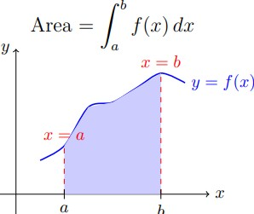

Figure 1:

In the field of Mathematics, to achieve the high precision numerical integration formulas becomes one of the challenges [2]. The Newton-Cotes formulas are the most common numerical integration schemes [4]. It is assumed that the value of a function *f*(*x*) defined on [*a,b*] is known at equally spaced points *xi*, for *i* = 0*,*1*,*2*,...,n*, where *x*0 = *a* and *xn* = *b*.

The general form for open Newton-Cotes of degree *n* is stated as:

Z *b n*−1 *f*(*x*)*dx* ≈ X *wif*(*xi*) (1) *a i*=1

where there are (*n* − 1) distinct points, such that *a < x*1 *<* ··· *< xn*−1 *< b*, *xi* = *a* + *ih*, *i* = 1*,*2*,*···*n* − 1 , and (*n* − 1) weights *w*1*,*··· *,wn*−1, with. An integration method of the form (1) is said to be of order *P* if it produces accurate results *En*[*f*] = 0 for all polynomials of degree less than or equal to *P* [7]. Some of the open Quadrature formulas are derived depending on different values of *n*: For *n* = 1: Midpoint rule

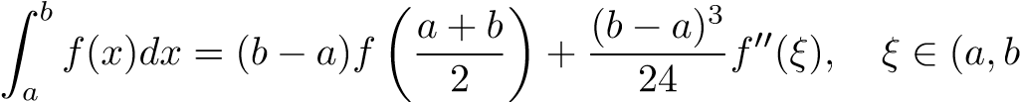) (2)

For *n* = 2: Open trapezoidal rule

) (3)

It is known that the degree of precision is (*n* − 1) for open Newton-Cotes formulas [8].

Several works have been carried out to improve the order of accuracy of the existing Newton-Cotes rules. Dehghan et al. [5, 6] improved open and semi-open Newton-Cote’s formula by including the location of boundaries of the interval as two additional parameters. Clarence O.E Burg [3] introduced a different approach by using first- and higher-order derivatives at the evaluation locations within the open NewtonCote quadrature to increase the precision and order of accuracy.

The motivation of this research paper is to introduce new derivative-based open Newton-Cotes Rules for numerical integration which uses mean of arithmetic mean and geometric mean at derivative value. These schemes are discussed in section 1.1.1 and in section 1.1.2, the error terms for the proposed schemes are also derived. Lastly the numeric examples are solved to show the effectiveness of the proposed schemes in section 1.1.3.

# Methodology: In this Section, a new formula is derived by using the mean of arithmetic mean and geometric mean at the interior points (*a,b*) in Open Newton-Cotes quadrature formula for the evaluation of a definite integral.

## Open Newton-Cotes Rules with Derivatives

* ▶ **Open Midpoint Rule (n=1)** using mean of arithmetic and geometric means:

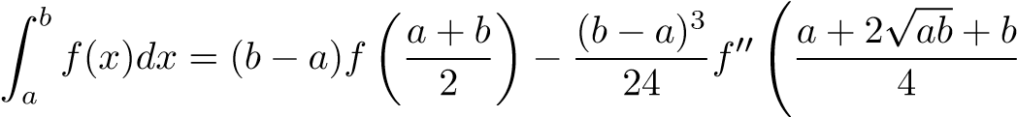!

(4)

**Precision:** 2 (vs. 1 for classical open midpoint rule).

**Proof:** For *f*(*x*) = *x*2, the exact value of Using equation (4):

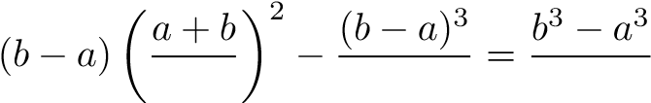

Simplifying: 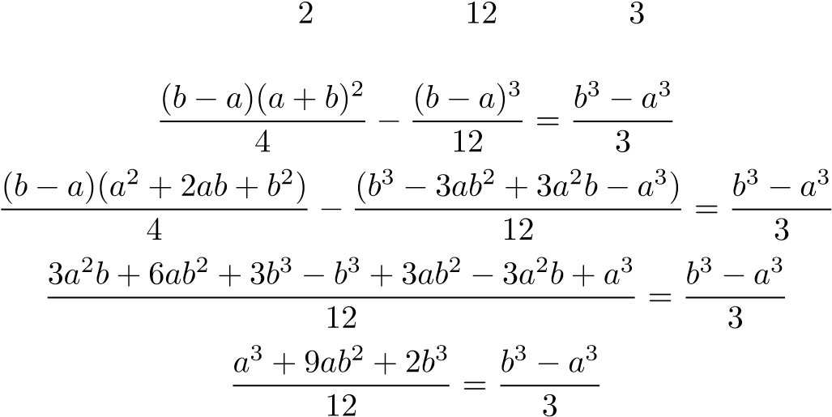

After further simplification, we verify both sides are equal. Thus, the solution is exact. Therefore, the precision of the open Midpoint rule with mean of A.M and G.M is 2 whereas the precision of the existing open Midpoint rule is 1.

* ▶ **Open Two-Point Rule (n=2)** using mean of arithmetic and geometric means:

!

(5)

**Precision:** 3 (vs. 2 for classical open two-point rule).

**Proof:** For *f*(*x*) = *x*3, the exact value of Using equation (5):

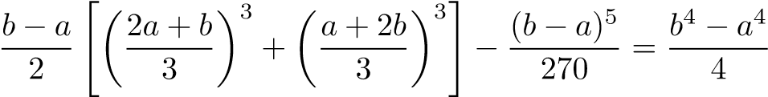

Expanding and simplifying:

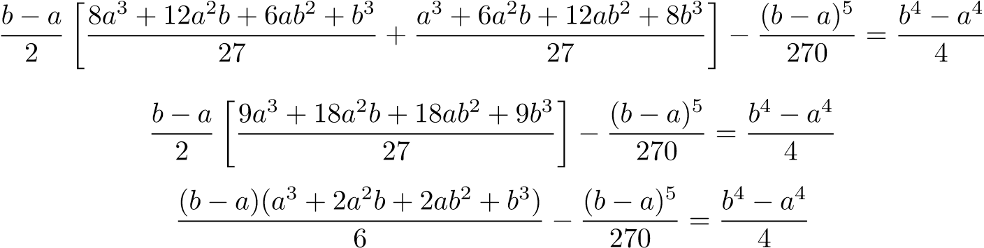

After detailed algebraic manipulation, we verify both sides are equal. Thus, the solution is exact. Therefore, the precision of the open Two-Point rule with mean of A.M and G.M is 3 whereas the precision of the existing open Two-Point rule is 2.

## Error Terms of the Proposed Method: In this section, the error terms for the mean of arithmetic and geometric means derivative-based Open Newton-Cotes quadrature rules are derived. The error terms are obtained by using the difference between the quadrature formula for the monomial and the exact result , where *p* is the precision of the quadrature formula.

### • Error term for Open Midpoint Rule (n=1):

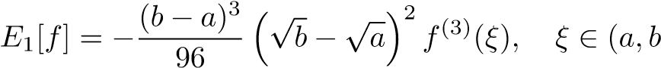) (6)

### Proof: Let

Using the Open Midpoint Rule (Equation 5):

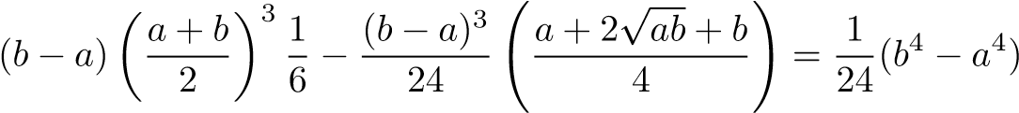

After simplification:

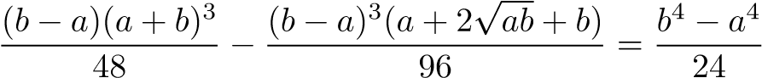

The difference between the exact and approximated values yields:



Thus, the error term is verified.

### • Error term for Open Two-Point Rule (n=2):

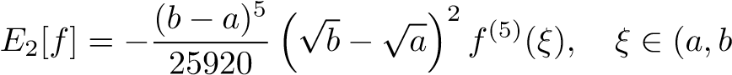) (7)

### Proof: Let

Using the Open Two-Point Rule (Equation 6):



After expansion and simplification:



The difference between the exact and approximated values gives:



Thus, the error term is verified.

## Numerical Examples: In this section, some integrals are computed in order to compare the effectiveness of Open Newton-Cotes formulas and the proposed method.

### Example #1:

(Zhao and Li 2013; T.Ramachandran et al 2016)

### Example #2: , Example #3:

Since the exact value of the integral in **Example 3** is not available analytically, it has been approximated to **10 significant digits** for error estimation. **Tables 1 to 3** present the results for **Examples 1 to 3** using the *Open Midpoint Rule* (*n* = 1) and its modified form. **Tables 4 and 5** extend this comparison to the *n* = 2 case using the *Open Two-Point Rule* and its modified counterpart.The **Number of Iterations** indicates the number of equally spaced subintervals used in the composite rules. **Figures 1 to 5** display the absolute error for each example, comparing the accuracy of the classical and modified methods. The absolute error is defined as:

|Exact value − Approximated value|

|  |  |  |  |  |
| --- | --- | --- | --- | --- |
| Iterations | Open Midpoint Rule | | Modified Open Midpoint Rule | |
|  | Approximate Value | Error | Approximate Value | Error |
| N=1 | 5.436564 | 0.952492 | 5.987654 | 0.401402 |
| N=2 | 6.128731 | 0.260325 | 6.345678 | 0.043378 |
| N=3 | 6.305412 | 0.083644 | 6.378901 | 0.010155 |
| N=4 | 6.521610 | 0.132554 | 6.401012 | 0.011956 |
| N=5 | 6.474017 | 0.084961 | 6.390660 | 0.001604 |

Table 1: Open Midpoint Rule vs Modified Open Midpoint Rule (n=1)for

|  |  |  |  |  |
| --- | --- | --- | --- | --- |
| Iterations | Open Midpoint Rule | | Modified Open Midpoint Rule | |
|  | Approximate Value | Error | Approximate Value | Error |
| N=1 | 0.785398 | 0.214602 | 0.908998 | 0.091002 |
| N=2 | 0.948059 | 0.051941 | 0.992694 | 0.007306 |
| N=3 | 0.977049 | 0.022951 | 0.998389 | 0.001611 |
| N=4 | 0.987116 | 0.012884 | 0.999454 | 0.000546 |
| N=5 | 0.991762 | 0.008238 | 0.999765 | 0.000235 |

Table 2: Open Midpoint Rule vs Modified Open Midpoint Rule (n=1)for

|  |  |  |  |  |
| --- | --- | --- | --- | --- |
| Iterations | Open Midpoint Rule | | Modified Open Midpoint Rule | |
|  | Approximate Value | Error | Approximate Value | Error |
| N=1 | 0.2379689798 | 0.0022575272 | 0.2430485380 | 0.0028220310 |
| N=2 | 0.2400312416 | 0.0001952654 | 0.2403412102 | 0.0001147032 |
| N=3 | 0.2401845816 | 0.0000419254 | 0.2402411278 | 0.0000146208 |
| N=4 | 0.2402128028 | 0.0000137042 | 0.2402297025 | 0.0000031955 |
| N=5 | 0.2402208042 | 0.0000057028 | 0.2402274641 | 0.0000009571 |

for

|  |  |  |  |  |
| --- | --- | --- | --- | --- |
| Iterations | Open Two-Point Rule | | Modified Open Two-Point Rule | |
|  | Approximate Value | Error | Approximate Value | Error |
| N=1 | 6.429728 | 0.031672 | 6.402409 | 0.013353 |
| N=2 | 6.391210 | 0.002154 | 6.389274 | 0.000218 |
| N=3 | 6.389489 | 0.000433 | 6.389076 | 0.000020 |
| N=4 | 6.389194 | 0.000138 | 6.389060 | 0.000004 |
| N=5 | 6.389113 | 0.000057 | 6.389057 | 0.000001 |

for

|  |  |  |  |  |
| --- | --- | --- | --- | --- |
| Iterations | Open Two-Point Rule | | Modified Open Two-Point Rule | |
|  | Approximate Value | Error | Approximate Value | Error |
| N=1 | 0.2397689798 | 0.0022575272 | 0.2430485380 | 0.0028220310 |
| N=2 | 0.2400312416 | 0.0001952654 | 0.2403412102 | 0.0001147032 |
| N=3 | 0.2401845816 | 0.0000419254 | 0.2402411278 | 0.0000146208 |
| N=4 | 0.2402128028 | 0.0000137042 | 0.2402297025 | 0.0000031955 |
| N=5 | 0.2402208042 | 0.0000057028 | 0.2402274641 | 0.0000009571 |

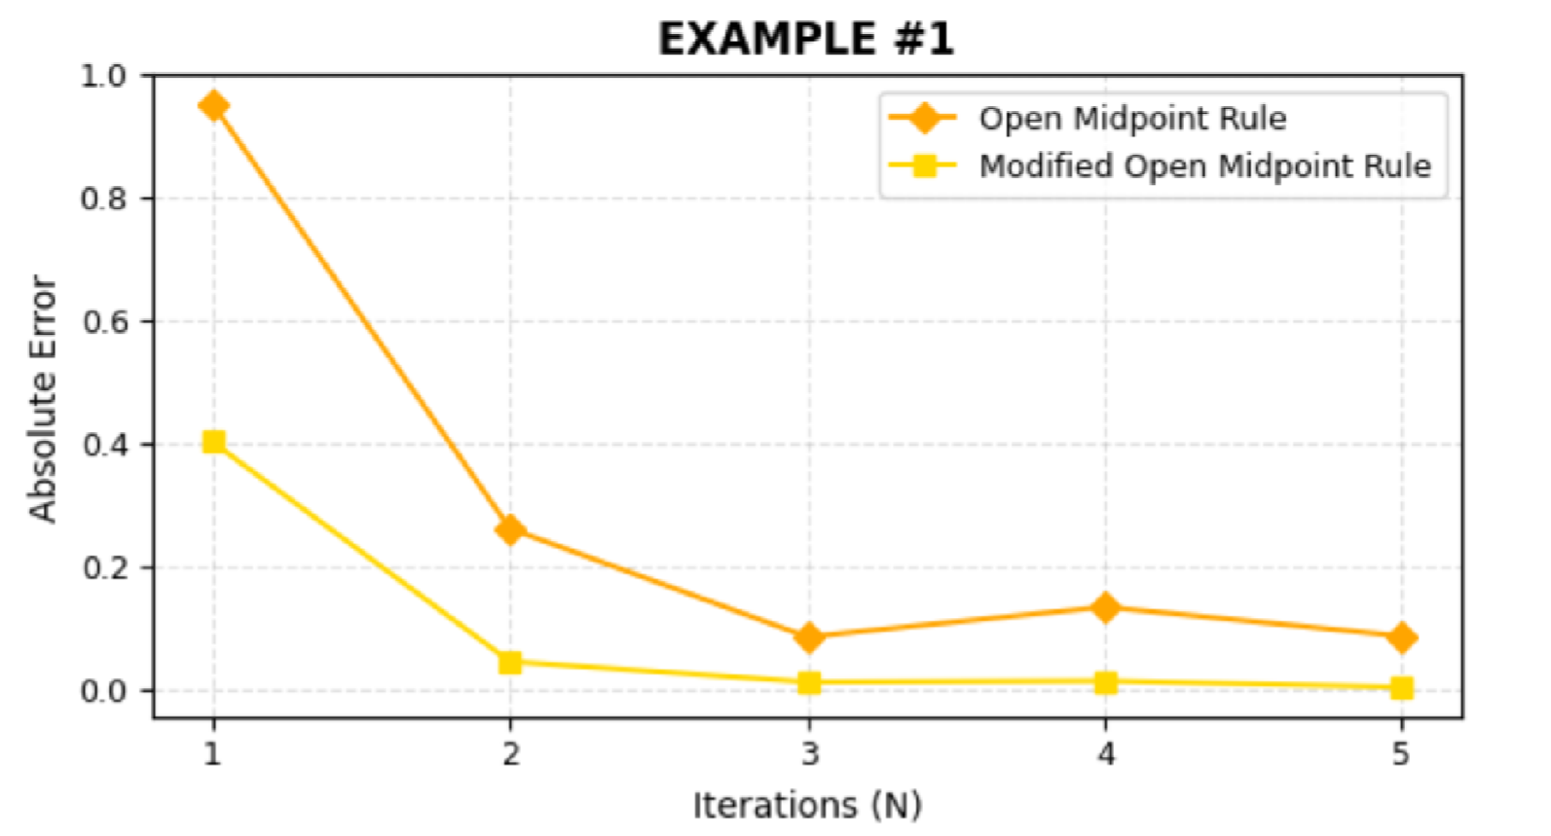for

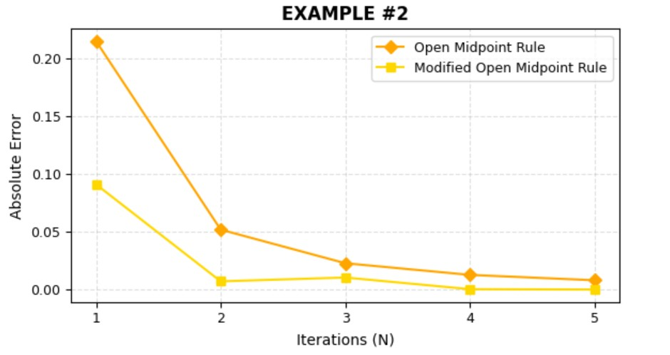

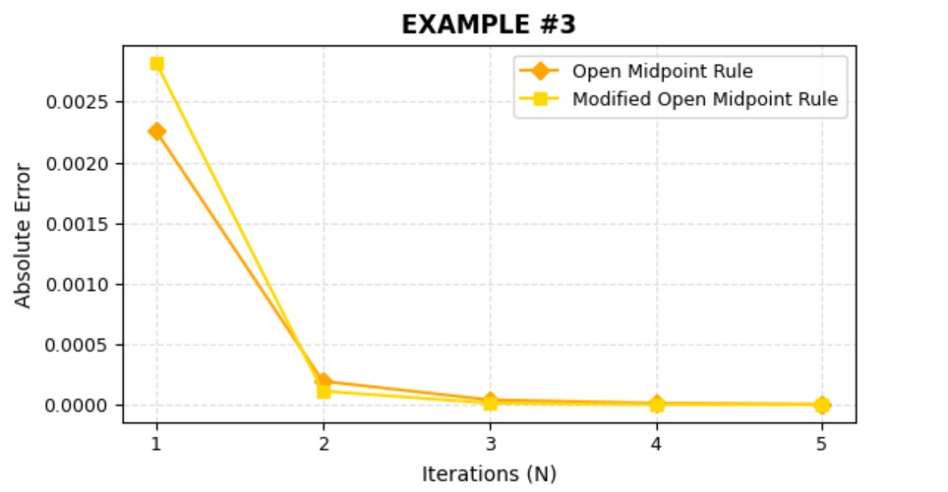

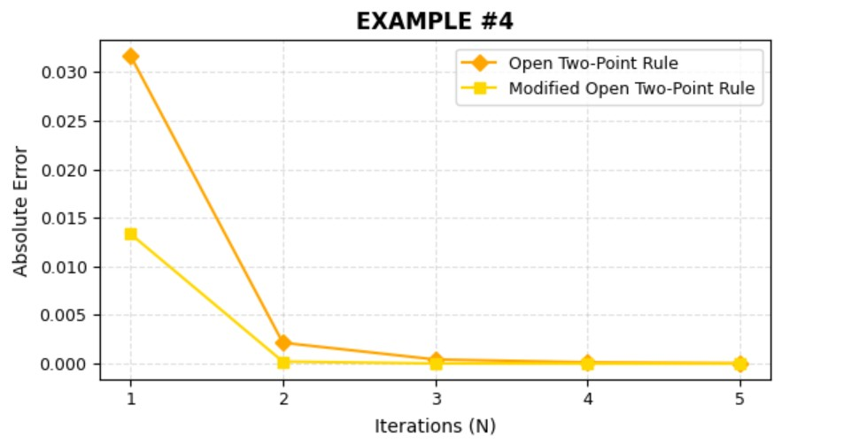

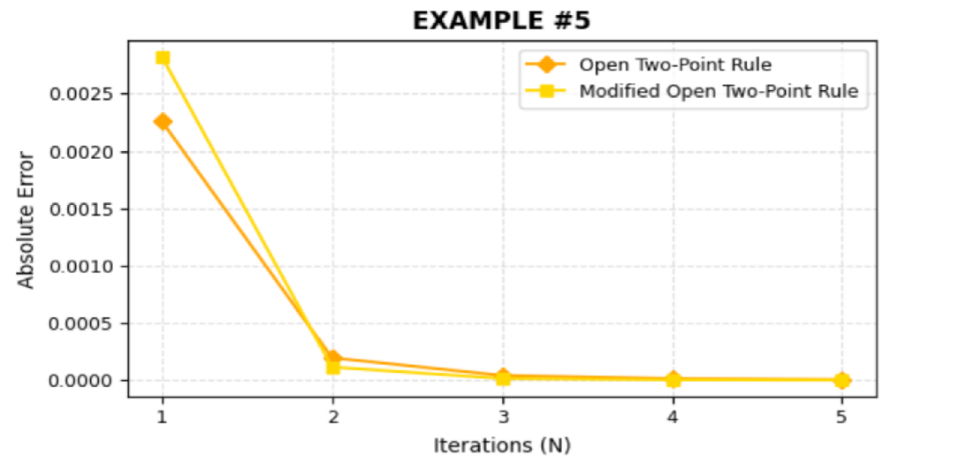

# Conclusion

The conclusion of this paper can be summarized as: A new family of numerical integration of open NewtonCotes is introduced which uses the mean of arithmetic and geometric means at derivative value. It is proved that the proposed method is more efficient than classical open Newton-Cotes formulas. The error terms are calculated by using the concept of precision. The numerical values are also given to show the accuracy of the proposed method.

# References

1. Atkinson, K.E. (1989) An Introduction to Numerical Analysis. 2nd Edition, John Wiley & Sons. New York
2. Bailey, D.H. and Borwein, J.M., 2011. High-precision numerical integration: Progress and challenges. Journal of Symbolic Computation, 46, pp.741-754.
3. Burg, C.O., 2012. Derivative-based closed Newton-Cotes numerical quadrature. Applied Mathematics and Computation, 218(13), pp.7052-7065.
4. Chapra, S.C. and Canale, R.P., 2010. Numerical methods for engineers. Boston: McGraw-Hill Higher Education.
5. Dehghan, M., Masjed-Jamei, M. and Eslahchi, M.R., 2005. On numerical improvement of closed NewtonCotes quadrature rules. Applied Mathematics and Computation, 165(2), pp.251-260.
6. Dehghan, M., Masjed-Jamei, M. and Eslahchi, M.R., 2006. On numerical improvement of open NewtonCotes quadrature rules. Applied mathematics and computation, 175(1), pp.618-627.
7. M.K.Jain, S.R.Iyenger and R.K.Jain, (2007), Numerical methods for scientific and computation, New Age International (P) limited, Fifth Edition
8. KRYLOV, V. I. (1962). Approximate calculation of integrals. New York, Macmillan.